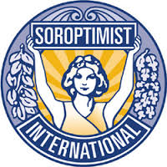
OPEN HEART – OPEN DOOR

SOROPTIMIST INTERNATIONAL EXCHANGE PROGRAM
Surprising opportunities for Soroptimists!
Are you looking for Soroptimist contacts worldwide?
Then sign up and participate in the Exchange Program Open Heart - Open Door, an initiative of SI Europe.
Friendship, International Goodwill and Understanding
Global Soroptimist Community
Exchange of professional expertise
International Hospitality
5 Options
- Home Hospitality: to one or two Soroptimists or a couple

- Contact Person: be a guide in your hometown

- Exchange Visit: on professional level

- Home-Exchange:
You and your exchange partner will stay at each other’s homes for a certain period by mutual agreement

5. Youth Exchange Program for Young Relatives,
e.g. daughter/son, niece/nephew, grandchild.

OHOD - Exchange Program was the idea of Heidrun Konrad, SIE Past President.
The objective is to connect Soroptimists worldwide.
OHOD has 500 Soroptimist participants since 1995.
If you are acquainted with Soroptimists who could be interested to join Open Heart - Open Door, inform them about this program. Open Heart – Open Door will open the worldwide Soroptimist horizon!
For registration or information about Open Heart – Open Door.
Please contact Liaison Officer Henny Knap-Go, SI Club Hilversum-NL.
hkhknapgo@upcmail.nl or visit European Federation: www.soroptimisteurope.org

